***Fatima bint Naseer***

***BSAI_3A_050***

**BFS without queue**:

This code uses recursion to do **Breadth-First Search (BFS)** on a graph stored as a dictionary. It visits nodes level by level, printing each one and keeping track of visited nodes to avoid repeats. Instead of a queue (used in normal BFS), it calls itself with the next level of nodes until all are explored.

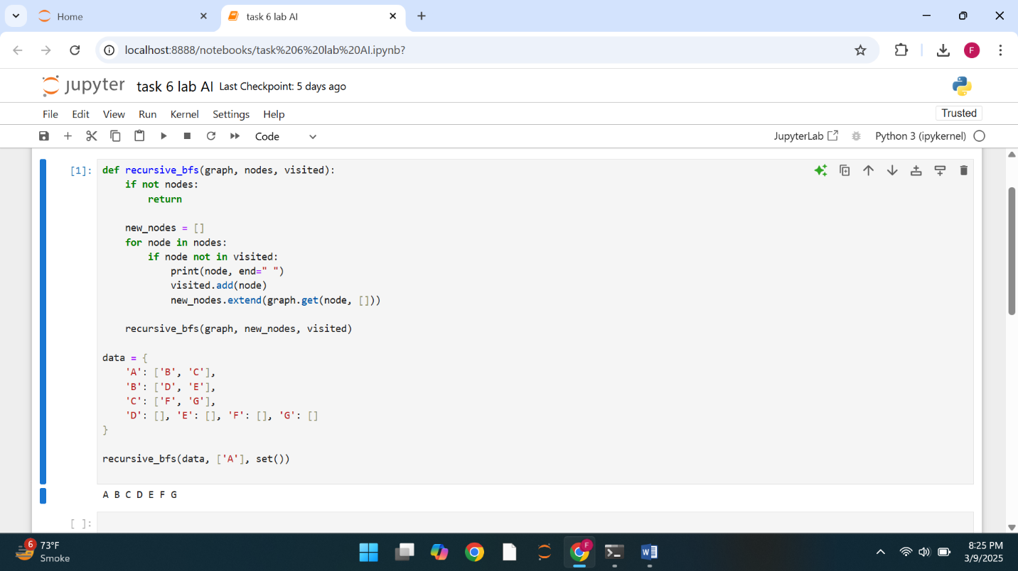

**BFS without node:**

This code creates a **GraphNode** class to represent graph nodes and uses **Breadth-First Search (BFS)** with a queue. It starts from a given node, prints each node as it visits, and keeps track of visited nodes to avoid duplicates. A sample graph with nodes **A to G** is built, and BFS begins from node **A**.

